Last December, when the smoking rate among adults in New York City fell below the 12% benchmark set by health advocates, the city health department attributed the achievement in-part to a 2017 law that raised tobacco taxes.

The city took several other steps to curb smoking that year, including a cap on the number of tobacco vendors in the city and disallowing the sale of cigarettes in pharmacies. The tax hike raised the price of a pack of cigarettes to $13, the highest price in the country. On the surface, those measures appear to be working, as New York City has the lowest smoking and lung cancer rates of any place in the state, despite being the state’s largest urban center with the highest density of tobacco vendors per mile.

“More New Yorkers than ever have extinguished their smoking habit – or never even picked it up – and we’re all healthier for it,” said Health Commissioner Dr. Dave A. Chokshi last December.

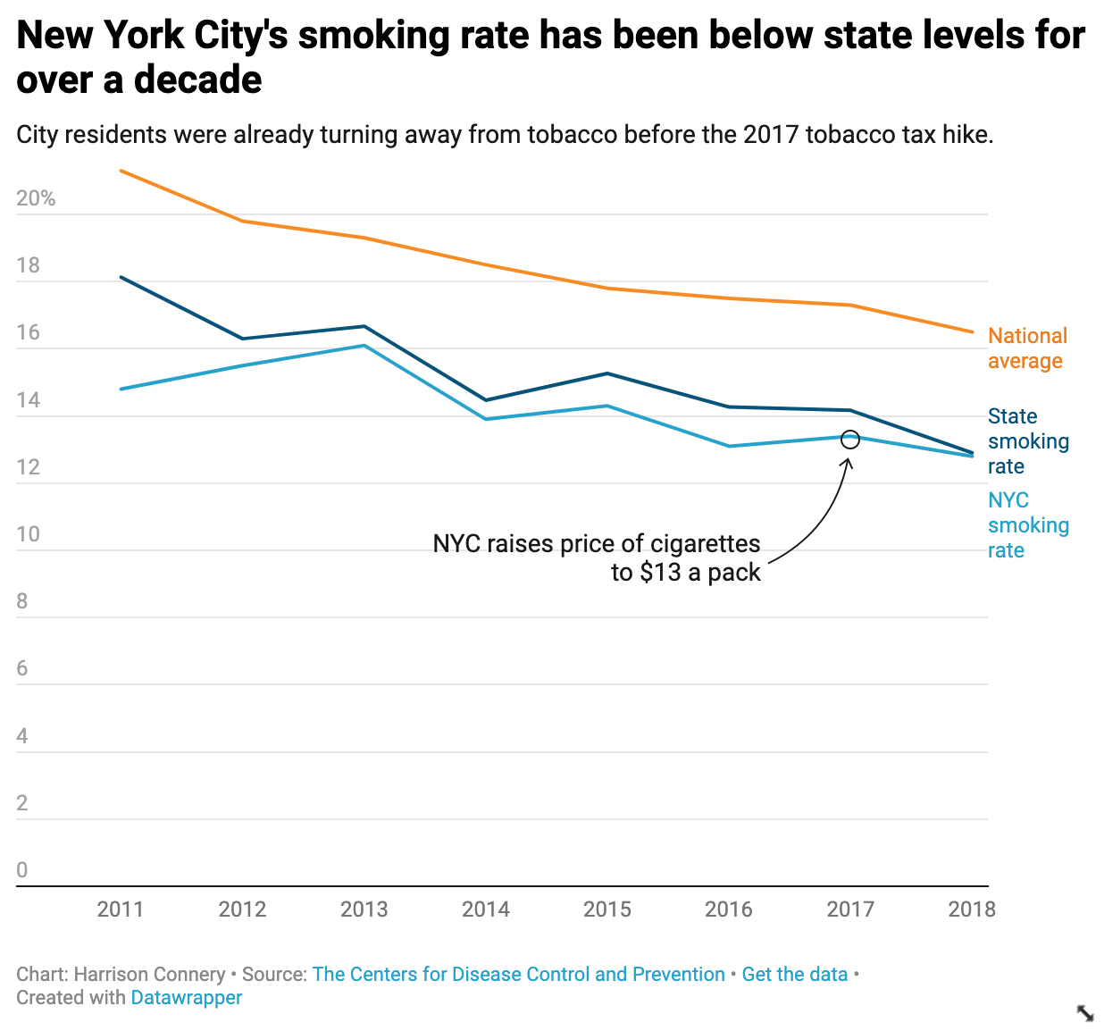

<https://datawrapper.dwcdn.net/uAe4s/2/>

But in 2017, New York City’s smoking rate was already lower than the state rate, and had been for years. Smoking was on the decline in both areas. So is it correct to claim that new regulations are responsible for the smoking rate falling below 12%, or are there other explanations, or are there other factors at play? Raymond Niaura, interim chairman of the Department of Epidemiology at New York University, suggested some of the decline could be due to demographic changes in the city. Wealthier, more educated people are less likely to smoke than poorer, less-educated people. As the city gentrifies, more of the former group continue to move in, while those in the latter group are priced out. But those remaining are more greatly impacted by the city’s high tobacco tax, none more so than the severely mentally ill, who are much likelier to smoke than any other demographic. Although taxes get some people to quit smoking, particularly cash-strapped teenagers, the fact that roughly 12% of adults continue to smoke in New York City despite the high price of cigarettes suggests that the taxes aren’t effective enough in their current incarnation to eliminate the habit altogether.

“You’ve got to wonder whether [tobacco taxes] kind of reached the limit of their effectiveness, because we still have a huge chunk of the population still smoking,” said Niaura.

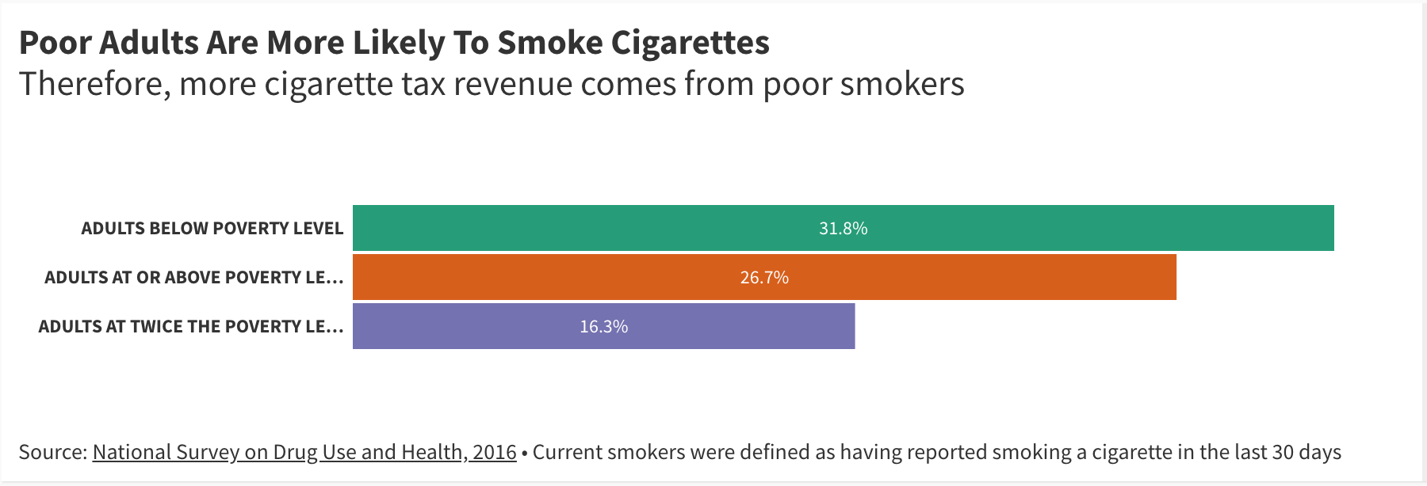

Experts and advocates say the political will isn’t there to dramatically alter the tobacco landscape with further taxes or to provide more help for current smokers to quit. Although New York City raised taxes on cigarettes in 2017, the tax at the state level hasn’t increased since 2010, making it one of 27 states that haven’t raised tobacco taxes over the past decade.

“States and the federal government are as addicted to the tax as individuals are to the nicotine,” said David Abrams, professor social and behavioral sciences at NYU. “They don’t really want too many people to quit because the tax revenue will go down dramatically.”

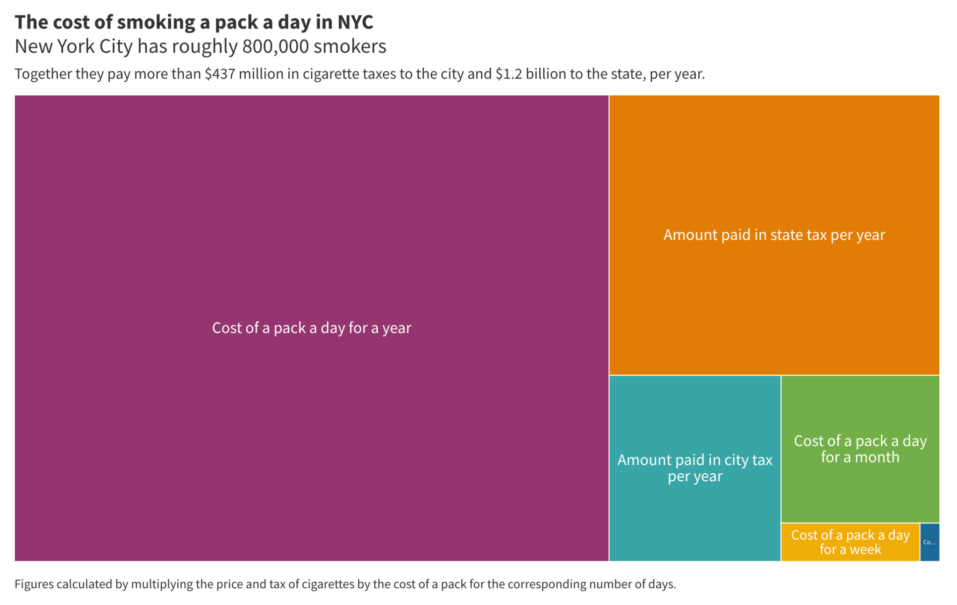

<https://public.flourish.studio/visualisation/5973364/>

On top of that, much of the money gained from tobacco taxes, as well as money won by the landmark 1998 Master Settlement Agreement, hasn’t gone to smoking cessation initiatives as intended, but instead to states’ general funds. That leaves smokers addicted to cigarettes in an awkward position: on the one hand, cigarettes are very expensive; on the other, they have limited resources to quit and a pack of cigarettes isn’t prohibitively expensive.

The 1998 Master Settlement Agreement was a landmark case that forced tobacco companies to pay settlement fees in perpetuity for the public harm caused by tobacco products, with the first $206 billion to be paid over 25 years, according to a 2001 report from the Government Accountability Office.

“The way the government was successful in that action was basically arguing that the tobacco companies have to pay for the health consequences of their cigarettes,” Niaura said. “But if you look at how that money was actually spent, most of it went into state general funds and they ended up fixing roads and doing other stuff.”

Different states used the money in different ways. Rhode Island committed the entirety of its first $685 million to float a loan to balance its budget in 2002, according to a 2017 report from the state Office of the Attorney General. New York allocated some of the money to healthcare, but also put 37% of the payments it received by 2001 into a rainy day fund. New York City used its early revenue to fund capital projects, including the construction of new schools. In 2020, New York state received over $1.9 billion in revenue from settlement payments and tobacco taxes in 2020, and allocated under $40 million to prevention programs, according to the Truth Initiative, an anti-smoking advocacy group. That’s 20% of what the Centers for Disease Control and Prevention recommends the state spend.

“There’s somewhat of a symbiotic relationship between tobacco companies and governments, because governments know if we need some more quick revenue we can raise tobacco taxes, and not only do we get the revenue, but we look like the good guys,” Niaura said. “And because people are addicted to cigarettes, prices are not very elastic and that’s why you have people who are willing to spend exorbitant amounts of money to maintain their habit.”

Trevor Summerfield, director of advocacy for New York, Vermont and Massachusetts for the American Lung Association, said his organization lobbied unsuccessfully for a $1 tax increase on cigarettes at the state level last year, even though the ALA projects doing so would raise tax revenue by $39 million.

“There were other priorities this legislative session than a cigarette tax,” Summerfield said.

Meanwhile, the ALA estimates that over 22,000 New Yorkers die each year from smoking, a figure it places at 480,000 nationally. Most of those people are at or below the poverty level: the CDC reports the smoking rate for those below the poverty level is twice that of adults who earn twice the poverty level.

“It has to do with the issue of health being more salient to people who have the means to do something about their own health,” said Niaura.

The heaviest smokers tend to be people with severe mental illness, because smoking can temporarily relieve symptoms of mental illness, particularly schizophrenia, according to Mental Health America.

Abrams said the general public might have fatigue from years of anti-tobacco campaigning.

“Talking about the fact that half a million die prematurely every year and could be prevented; if you talk about that for 20 years, after 5 or 6 years people are like, ok, so what’s new? It becomes a part of the background and therefore it’s not as tragic,” he said. “The background deaths are the background deaths.”